**Probability and Statistics - IT2120**

Lab-07

IT24102372-Wijesinghe D.H.R.

Exercise

1)

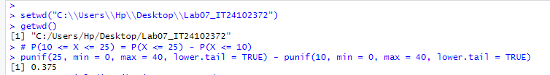

2)



3)



2.

